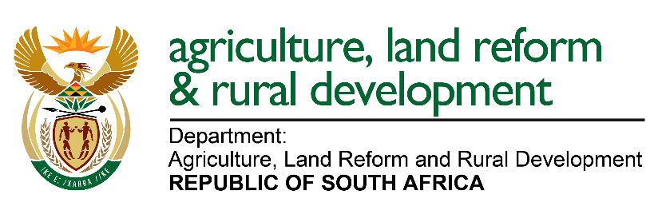 | DIRECTORATE: FOOD SAFETY AND QUALITY ASSURANCE  SUB-DIRECTORATE: AGRICULTURAL PRODUCT QUALITY ASSURANCE
April 2024
Deputy Director: Dr Mbulaheni Thomas Mutengwe; Tel No: (012) 319 6121; Fax: (012) 319 6265; E-mail: MbulaheniM@dalrrd.gov.za

Division: Animal and Processed Products | Division: Fresh Fruits and Flowers | Division: Agronomy and Vegetables
Scientist Manager: Vacant (Acting: Niel Erasmus)  (012) 319 6027  (NielE@dalrrd.gov.za) | Manager: Mr Dzivhuluwani Ernest Nndwambi  (012) 319 6474  (ErnestN@dalrrd.gov.za) | Manager: Mr Malose Fache  (012) 319 6334  (MaloseF@dalrrd.gov.za)
Ms Purity Mkhize 319 6106  (PurityM@dalrrd.gov.za)  Edible Vegetable Oils (Draft)  Eggs  Frozen Fruit & Frozen Vegetables  Honey  Jam, Jelly and Marmalade  Poultry Meat  Ms Thabang Rampa 319 6093  (ThabangK@dalrrd.gov.za)  Coffee, Chicory & Related Products  Dairy and Imitation Dairy Products  Geographical Indications  Honeybush  Rooibos  Mayonnaise & Salad Dressings  Vinegar  Mr Niel Erasmus 319 6027  (NielE@dalrrd.gov.za)  Apricot and Peach Kernels  Dried Fruit  Tea and Related Products  Edible Ices  Canned Fruit  Canned Pasta  Canned Mushrooms  Mr Simphiwe Mathenjwa 319 6388  (SimphiweMat@dalrrd.gov.za)  Canned Vegetables & Pickled Vegetables  Certain Raw Processed Meat Products  Processed Meat Products  Fat spreads  Table Olives  Fruit Juice and Fruit Drink  Red Meat | Ms Tebogo Tshipana 319 6070  (TebogoC@dalrrd.gov.za)  Table grapes  Pineapples  Melons  Ms Dibetso Kekana 319 6231  (DibetsoK@dalrrd.gov.za)  Stone fruit (plums and prunes; apricots, peaches and nectarines)  Cherries  Fresh flowers  Mr Sidney Setlelele 319 6018  (MarutlaS@dalrrd.gov.za)  Subtropical fruit (mangoes, avocados and litchis)  Strawberries  Bananas  Ms Winnie Mafiri 319 6365  (WinnieM@dalrrd.gov.za)  Pome fruit (apples and pears)  Pomegranates  Mr Willy Madiba 319 6051  (MadibaW@dalrrd.gov.za)  Citrus fruit  Kiwi fruit  Other unspecified fruit (such as Papayas, Granadillas, Cactus pears, Persimmons, etc.)  Ms Ansie Els 319 6387  (AnsieE@dalrrd.gov.za)  All FBO registrations | Ms Caroline Makobe 319 6291  (CarolineL@dalrrd.gov.za)  Mr Victor Mapfumari 319 6171  (VictorM@dalrrd.gov.za)  Mr Marutloe Kgasago 319 6232  (MarutloeK@dalrrd.gov.za)  Barley  Buckwheat  Canola  Dry Beans  Feed Products  Garlic  Groundnuts  Leguminous Seeds  Lesser known types of Maize  Maize  Maize Products  Oil Seeds  Onions & Shallots  Popcorn Kernels  Potatoes  Pulses  Rice  Sorghum  Soya Beans  Sunflower Seeds  Tomatoes  Tree Nuts  Vegetables (Artichokes, asparagus, aubergines (as also known as eggplant or brinjals), beetroot, broccoli, brussels sprouts, butternuts, cabbages, carrots, capsicums (also known as sweet peppers), cauliflower, (also known as witloof chicory), chillies, chinese cabbages, courgettes, cucumber, cultivated mushrooms, endives, garlic, gem squashes, ginger, green beans, green onions (also known as chives), green peas, lettuce, okra, parsnips, pumpkins, radishes, sweet corn, sweet potatoes, tomatoes, turnips, fennel and scorzonera)  Wheat  Wheat Products

